**Lab 6**

**Modelling and Simulation of RC phase shift oscillator**

M Usman RP-20EE-420

um7995367[@gmail.com](mailto:faiz.raza.dec@gmail.com)

**Abstract:**

The RC phase shift oscillator is a commonly used electronic circuit that generates a sinusoidal waveform at its output. It consists of an op-amp or transistor amplifier and a network of resistors and capacitors that provide the necessary phase shift to sustain oscillations. Understanding the behaviour and characteristics of this oscillator is essential for circuit design and analysis. In this study, we present a comprehensive modelling and simulation approach for the RC phase shift oscillator. We begin by deriving the mathematical equations governing the circuit, considering the amplifier characteristics and the phase shift network. We then develop a simulation model using an appropriate electronic circuit simulation software.

**Introduction:**

The RC phase shift oscillator is a type of electronic oscillator that generates a sinusoidal waveform at its output without the need for external input signals. It is widely used in various applications, including audio oscillators, frequency synthesizers, and signal generators. Understanding the principles and characteristics of this oscillator is crucial for engineers and researchers involved in circuit design and analysis. The basic concept behind the RC phase shift oscillator lies in the use of a phase shift network to produce the required feedback for sustained oscillations. The phase shift network consists of a series of resistors and capacitors that provide a cumulative phase shift of 180 degrees or more at the desired oscillation frequency. This phase shift, combined with an amplifier, creates a positive feedback loop, enabling the oscillator to generate a continuous sinusoidal waveform.

**Mathematical Modelling:**

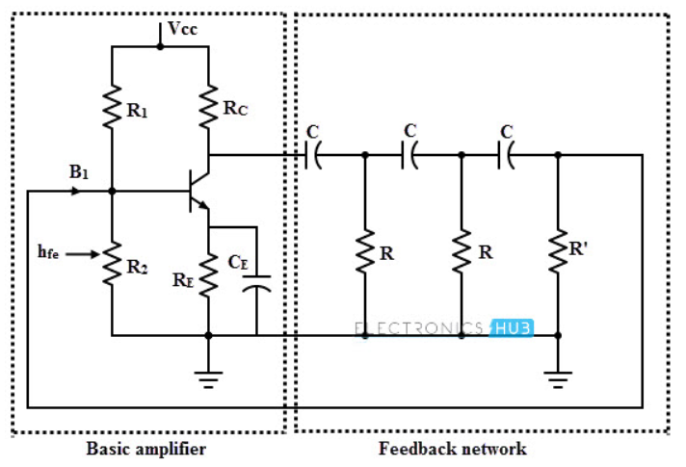

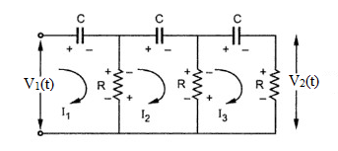

**Applying KVL 𝑜n Loop 𝟏:**

**−𝑉1(𝑡) + 𝑉𝐶(𝑡) + 𝑉𝑅(𝑡) = 0**

**R(𝑖1 − 𝑖2)+ ∫ 𝑖1𝑑𝑡 = 𝑉1(𝑡)**

**Taking Laplace transform**

**𝐼1(s) [𝑅 + ] − 𝑅𝐼2(𝑆) = 𝑉1(s) (1)**

**Applying KVL on Loop 2:**

**R(𝑖2 – 𝑖1)+**

**Taking Laplace transform**

**−𝑅I1 (𝑆) + 𝐼2 (𝑆) – 𝑅𝐼3 (𝑆) = 0 (2)**

**Applying KVL on Loop3:**

**R(𝑖3 – 𝑖2)+**

**Taking Laplace transform**

$$RI_{3}\left(s\right)-RI_{2}\left(s\right)+\frac{I_{3}\left(s\right)}{Cs}+RI_{3}\left(s\right)=0$$

$-RI_{2}\left(s\right)+I_{3}\left(s\right)\left[2R+\frac{1}{Cs}\right]=0$**(3)**

$$Matrix formed by the three equations is:$$

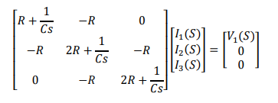

**Using cramer’s rule I3 is obtained**

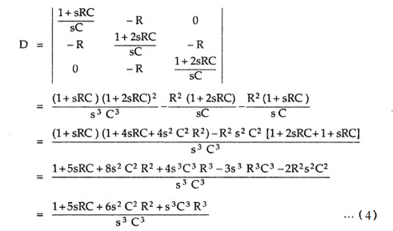

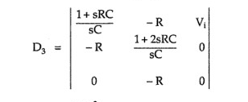

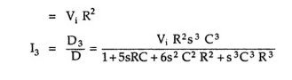

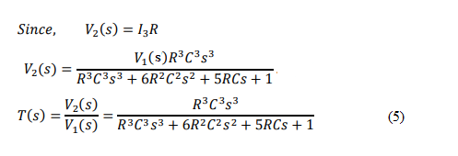

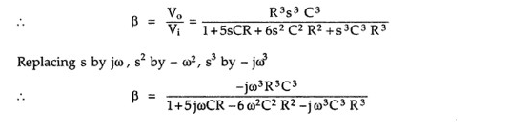

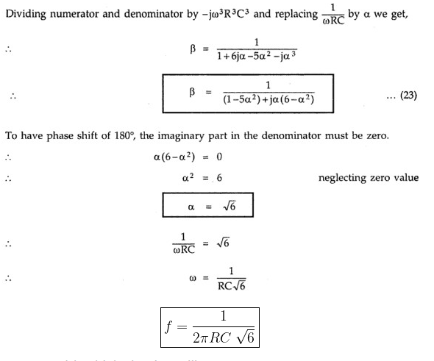

**Routh –Hurwitz Method:**

The Routh-Hurwitz method is a mathematical technique used for analyzing the stability of a linear time-invariant (LTI) system. It provides a systematic approach to determine the stability of a system by examining the signs of the coefficients of its characteristic polynomial. The characteristic polynomial of a linear system is obtained by setting the denominator of its transfer function equal to zero. It represents the equation that relates the system's input and output in the frequency domain. The Routh-Hurwitz method focuses on the coefficients of this polynomial to assess the stability of the system. To apply the Routh-Hurwitz method, the characteristic polynomial is arranged in a specific tabular form known as the Routh array. The Routh array is constructed by organizing the coefficients of the polynomial into rows, where each row corresponds to a power of the variable 's' in descending order.

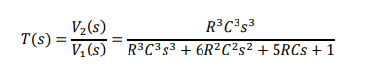

So making RH table

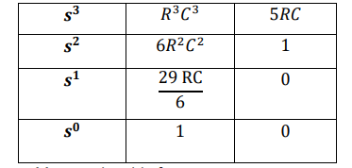

R.H table

We can see there are no sign changes in first column hence the given system is stable

**MATLAB\Simulink Implementation:**



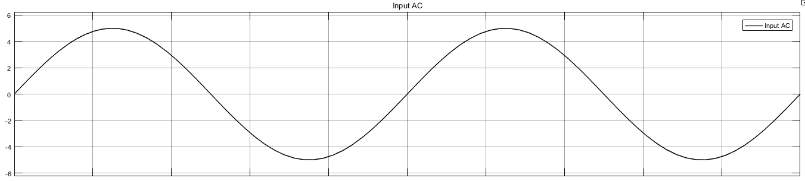

Fig1 input

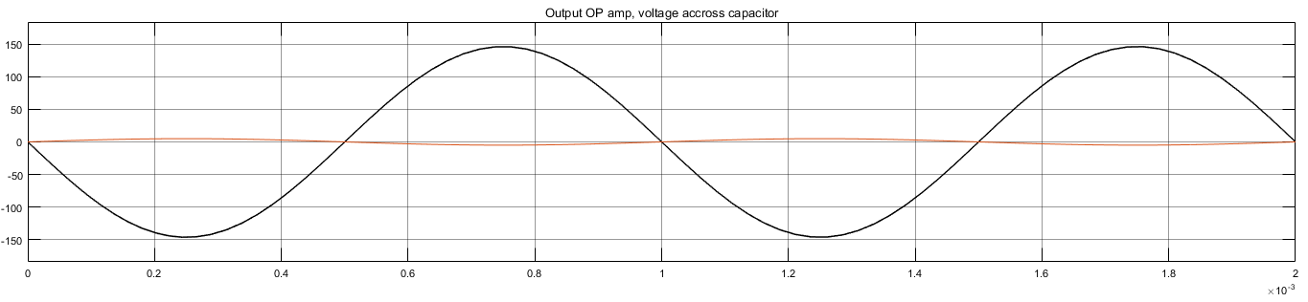

Fig2 Output with phase shift

**Multisim Implementation**:

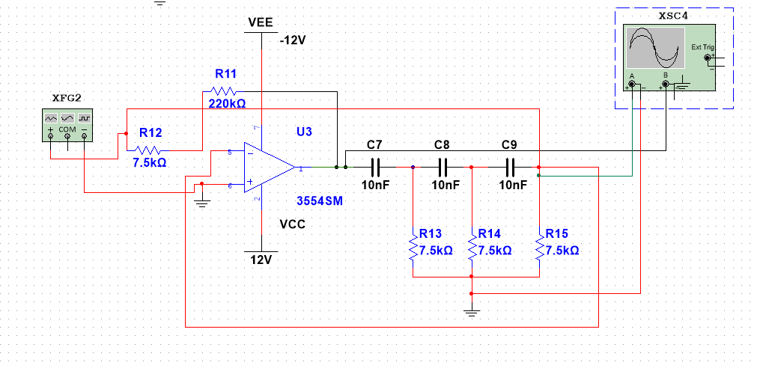

Fig3 Multisim circuit

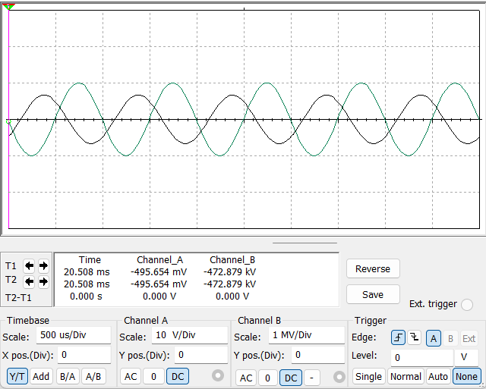

Fig4 Multisim output

**Conclusion:**

In this lab, we successfully conducted the modelling and simulation of the RC phase shift oscillator. Through our analysis, we gained valuable insights into the behavior, stability, and frequency response of the oscillator. We analyzed the stability of the oscillator using the Routh-Hurwitz method and identified the conditions for stable oscillation. By adjusting the phase shift network, we demonstrated how to achieve desired oscillation frequencies and minimize distortion. We also investigated the sensitivity of the oscillator to component variations and proposed techniques to improve its stability and frequency accuracy.

**Reference:**

[1] Norman S.Nise, Control systems engineering, 6th edition, John Willy and Sons, 2016.

[2] Umar Farooq, Lecture notes, control systems, 2022.